**Lab 1**

**NAME : محمد عبدالسلام عبدالمطلب**

**ID : 18011535**

**COMMUNCATION DEPARTMENT**

**( 3rd year )**

**Code 1:**

1. If user Enter all positive or all negative average will be printed zero
2. I use two variables neg_sum and pos_sum to calculate the average by avr = sum/num

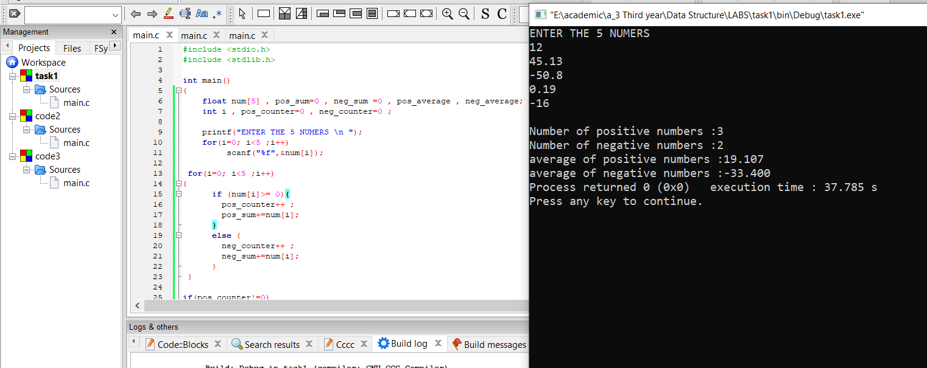

**Code 2:**

1. I use a fixed array sales_people to count salary in range.
2. I will take any number until -1.

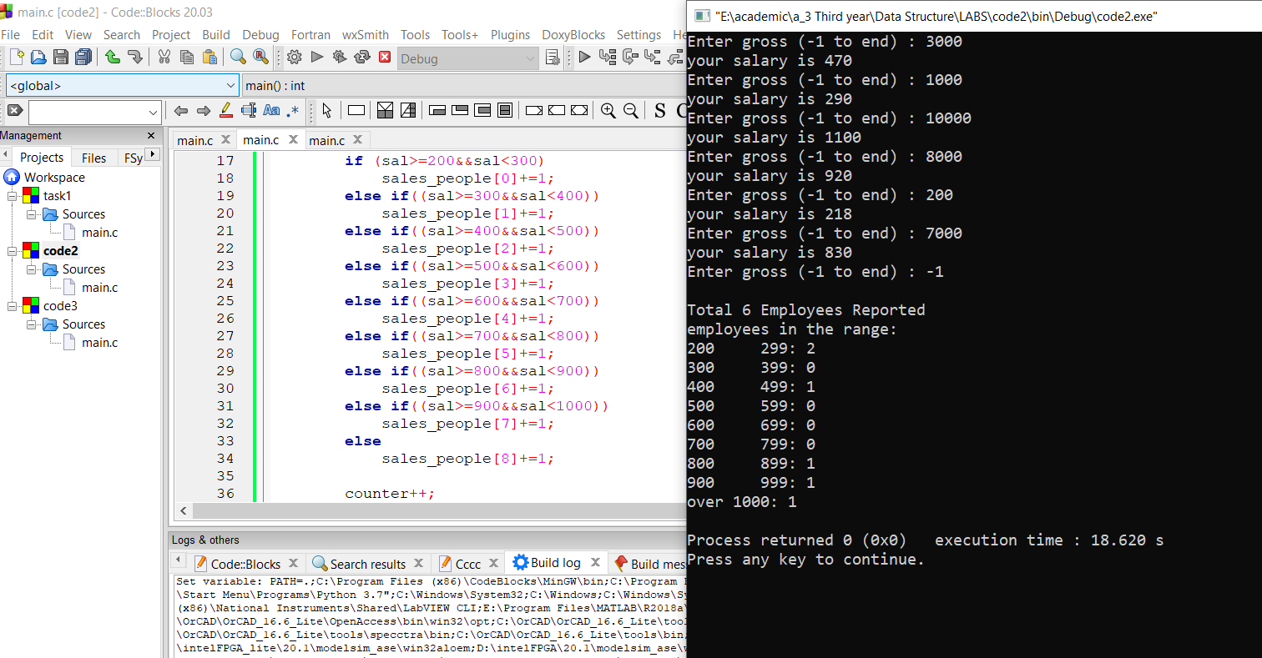

**Code 3:**

I use pointer only.

